Pat Reynolds
Deployment 5
Deploying containerized application

Part 1 – Setting up EC2 instances

- 3 Instances were launched, one with Jenkins, one with Terraform, and one with Docker
- Terraform and Docker ec2s also needed Default-JRE in order to be considered Jenkins agents

Issues

- As mentioned above. If Java is absent on the agents. When attempting to configure them in Jenkins it will be unable to connect as shown below.
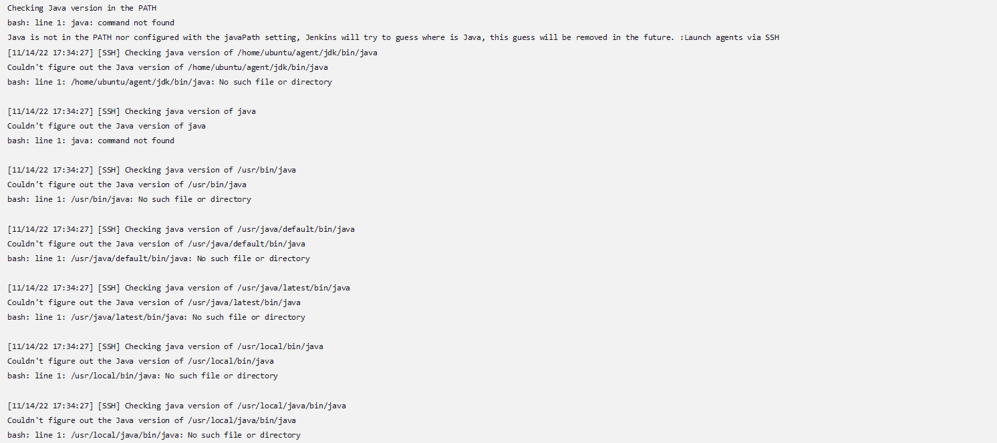
Part 2 – Pipeline configuration

- Added Build and Test stage, both will be handled by the Jenkins ec2
- Added Docker build, and Docker push stage, where the Docker ec2 will use a dockerfile to execute commands to containerize the application
- Added Terraform stages(init, plan, apply), which creates the environment that the application will live in.
- Added Docker plugin to Jenkins in order to avoid authentication errors when attempting to use docker commands.
- Added credentials to Jenkins in order to not fail the docker push stage
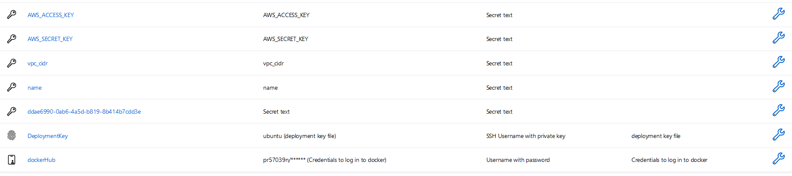
- Re-created dockerfile with a different set of instructions after finding that the deployed application failed.
- Added credentials as secret texts for better compatibility with Jenkins.

Issues

- If passing credentials using the docker login -u $(username) and -p ($password) flags as environmental variables. You’ll be notified that this is not only insecure, but groovy itself has problems reading the text. It passed my username perfectly fine, and censored my password, but was unable to actually sign in.
- There was an intention to just copy only the requirements.txt first, because I noticed that Jenkins copies the repository over to the agent by default, and after installing the requirements.txt then copy over the rest of the folder, however this did not work, as the application never launched despite the pipeline succeeding.
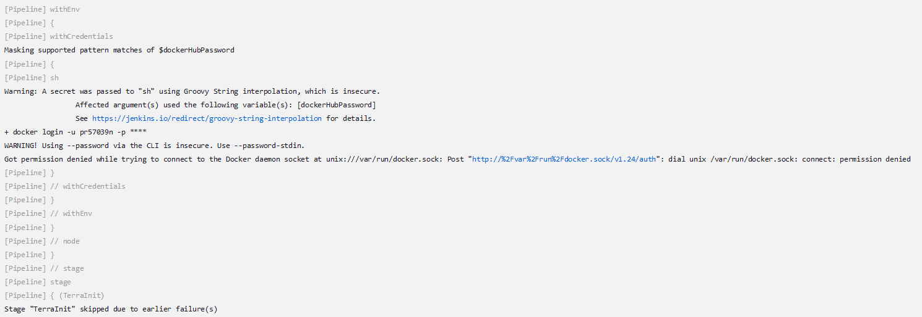

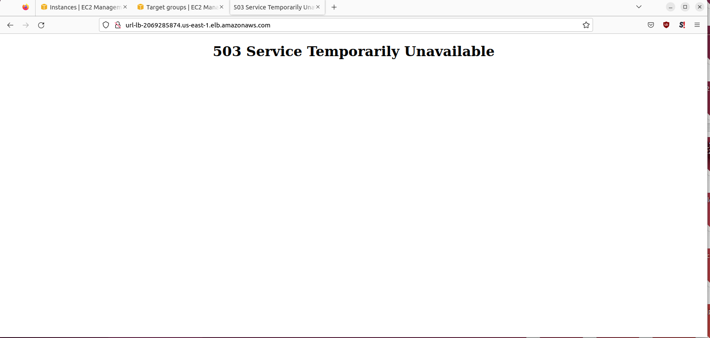

- All errors can be found in the GitHub repository under images/errors if unable to see them on this document.
Part 3 – Testing the Application

- Once the pipeline finished, the application cluster should appear under ECS
- It takes approximately 5-10 minutes, but after waiting a sufficient amount of time, I was able to access the application
- The application however is hosted utilizing a flask application, and when testing if it could handle any sufficient load, I was able to knock one of the two instances offline with repeat requests.
- In the future, it might be best to use gunicorn to host the application for better resilience to actual web traffic.
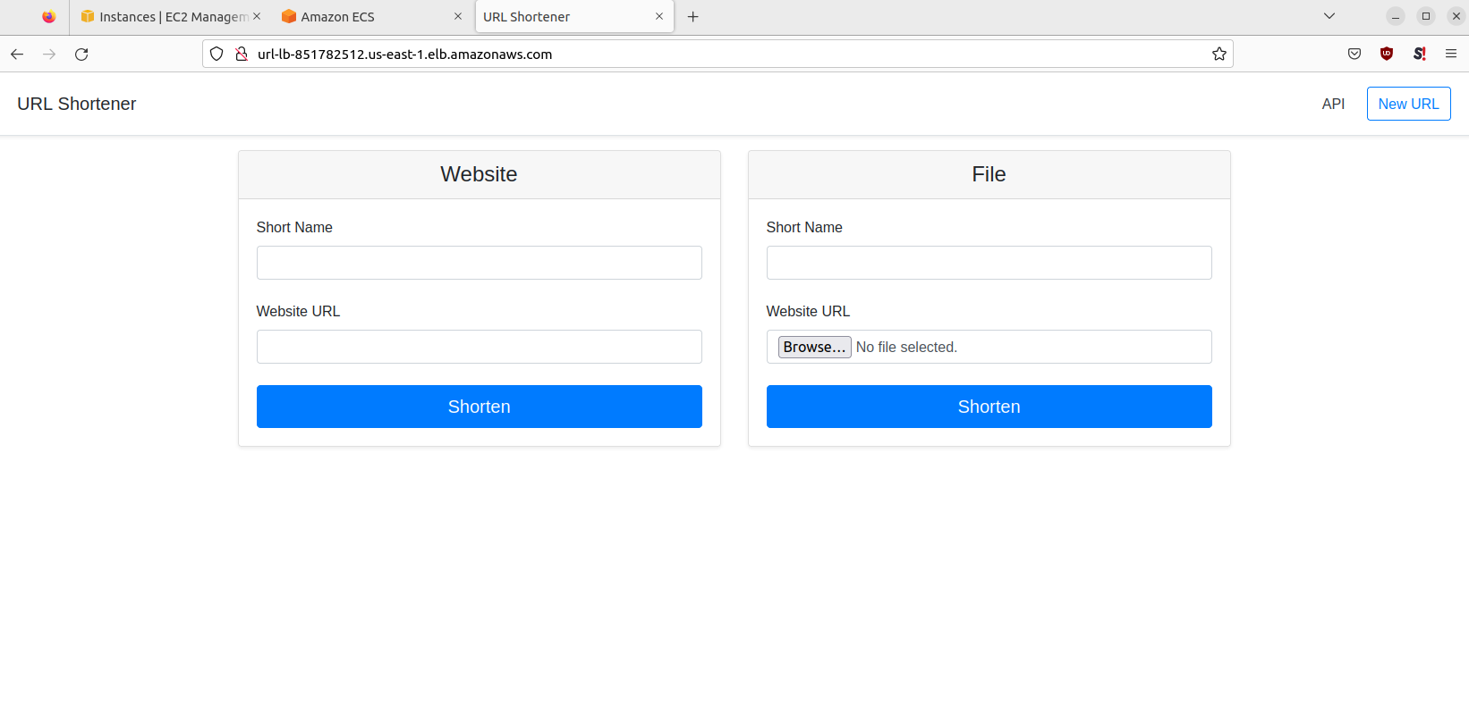

Issues

- Unfortunately, as stated before, there will, and is no indication if the application that is pushed to dockerhub utilizing that dockerfile actually works, so where you can build and test an application successfully, if your dockerfile is misconfigured you’ll move through the pipeline with a broken application
- There is very little information on ECS on how the application is actually functioning; if it’s down completely it gets in a loop of Pending and Provisioning, however if it’s down just due to a traffic barrage it’s only visible under the health check section.

Conclusions

- Docker is incredibly powerful for simplifying an automated pipeline, allowing what took a lot of manual setup to be done in less time (judging by the average runtime of each jenkins step).
- Docker adds a layer of fragility to the pipeline however, since unless you actively make sure your container actually works, there is a high risk of failure despite everything looking to work fine
- Ports and security groups once again come into play, if your target groups and ports are incorrect, the application will be inaccessible, similar to if you forget to open a port on an instance that an application communicates over.
- Flask once again proves, it cannot be used by itself for a production environment, gunicorn is more stable. This would require a revisit to change to port 8000 instead of 5000.

Adjustments

- I would add testing after the container is made. This possibly can be done with a cypress test of the application container right after containerizing the application. If the cypress test works then it would be fine to push the container to dockerhub
- Investigate variable passing through Jenkins, using secret texts was fine, but passing username + password as credential variables was not accepted by groovy, using ‘ and “ both yielded errors.

